AI-Based prediction of Electromagnetic Wave Attenuation in Lossy Media

(13 size) A Project Based Learning Report Submitted in partial fulfilment of the requirements for the award of the degree

of

Bachelor of Technology
in The Department of ECE
Electromagnetic waves and Transmission Lines & 24EC2209

Submitted by
2410040085-Poojitha
2410040036-Pallavi
2410040004-Sri Vyshnavi
2410040035-Anushree
2410040079-Rakshitha

Under the guidance of
Jitendra Sharma


Department of Electronics and Communication Engineering
Koneru Lakshmaiah Education Foundation, Aziz Nagar
Aziz Nagar – 500075
FEB - 2025.

Abstract

Accurate prediction of electromagnetic (EM) wave attenuation in lossy media is critical for applications in wireless communications, biomedical imaging, geophysical sensing, and radar systems. Traditional analytical approaches rely on complex frequency- and medium-specific calculations of the attenuation constant (α), making it difficult to generalize across diverse media such as seawater, soil, biological tissue, and concrete.
This project proposes an AI-based framework using an Artificial Neural Network (ANN) to predict EM wave attenuation in lossy media without the need to re-derive analytical formulae for each scenario. A dataset of over 10,000 samples is generated by computing α using the standard electromagnetic propagation formula across varying combinations of conductivity (σ), relative permittivity (εᵣ), relative permeability (μᵣ), frequency (MHz–GHz range), and distance. The ANN model, built with a 3-layer architecture (Input → Dense(64, ReLU) → Dense(64, ReLU) → Output), is trained using the Adam optimizer with MSE loss in TensorFlow/Keras.
The model is validated against analytical results and published datasets, targeting an R² score above 0.98 and less than 1% error compared to the classical formula. Deliverables include a trained model, the full attenuation dataset, evaluation scripts, and a comparative analysis report across five media types.
This work demonstrates the feasibility of using machine learning to enable fast, accurate, and generalized EM attenuation estimation — a practical tool for engineers working across multiple lossy media simultaneously.

List of Figures

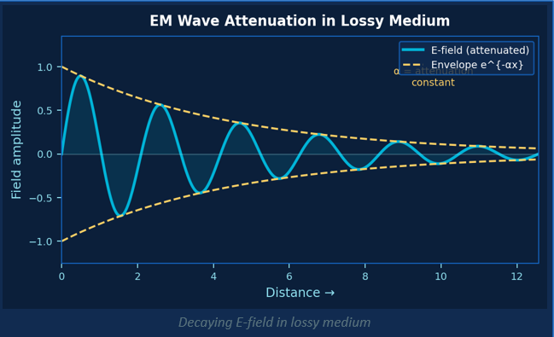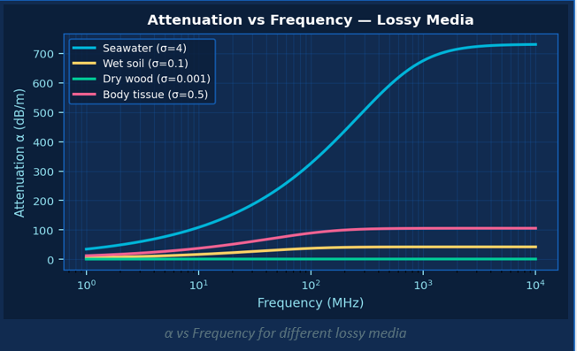

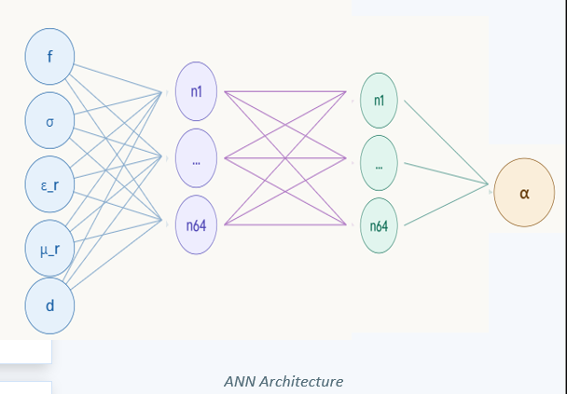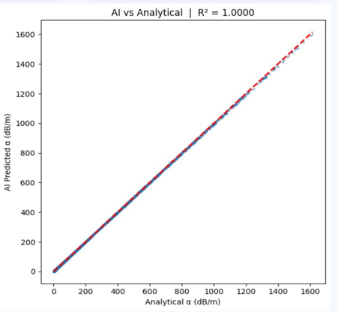

List of Tables

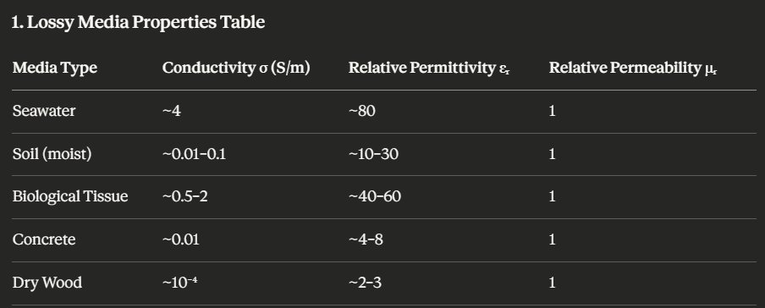

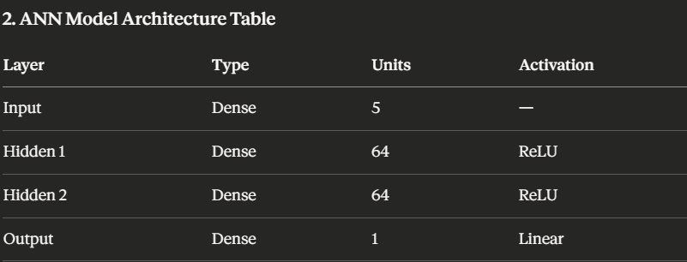

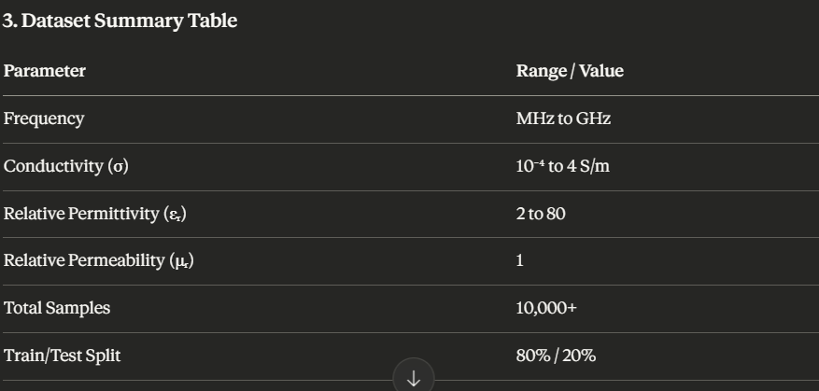
Table of Contents

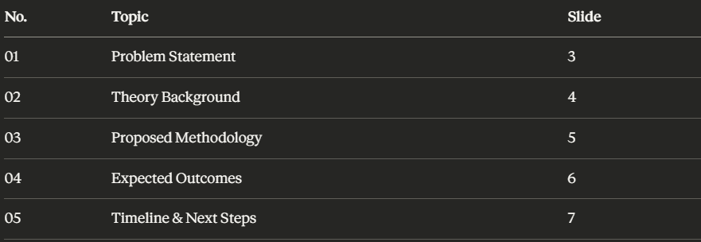

AI-Based prediction of Electromagnetic Wave Attenuation in Lossy Media

Introduction
Electromagnetic waves, when propagating through real-world media, undergo attenuation —gradual loss of signal strength caused by the electrical and magnetic properties of the medium. This phenomenon is particularly significant in lossy media such as seawater, moist soil, biological tissue, and concrete, where conductivity plays a dominant role in energy absorption. As wireless technologies continue to expand into domains like underground sensing, 5G communications, and biomedical imaging, the need for accurate and rapid attenuation prediction has become more critical than ever.
The attenuation constant (α), which quantifies this signal loss in Nepers per meter (Np/m), is governed by a well-established analytical formula involving the medium's conductivity (σ), relative permittivity (εᵣ), relative permeability (μᵣ), and the operating frequency (f). While this formula is theoretically precise, its practical application is cumbersome — engineers must re-derive or re-compute it for every unique combination of medium parameters and frequency, making it inefficient for generalized or large-scale use across multiple media types simultaneously.
Artificial Intelligence (AI), particularly Artificial Neural Networks (ANN), has demonstrated remarkable success in learning complex, non-linear relationships from data across scientific and engineering domains. By training a neural network on thousands of analytically computed attenuation values across diverse media and frequency ranges, it becomes possible to build a model that predicts α instantly, given only the input parameters — without requiring any manual formula evaluation. This approach not only accelerates computation but also generalizes well across media types that were not explicitly seen during training.

This project, developed under the Problem-Based Learning (PBL) framework for the subject Electromagnetic Waves and Transmission Lines (EMW & TL), aims to design, train, and validate such an AI-based attenuation prediction system. The outcome is expected to serve as a flexible, fast, and accurate tool for engineers working with EM wave propagation in diverse lossy environments.

METHODOLOGY
The methodology for this project follows a structured, five-phase pipeline designed to systematically build and validate an AI-based model for predicting electromagnetic wave attenuation in lossy media.
1. Data Generation
The foundation of the AI model lies in a high-quality, diverse dataset. Using the standard analytical formula for the attenuation constant (α), over 10,000 data samples are computed across a wide range of input parameter combinations. The input variables include conductivity (σ), relative permittivity (εᵣ), relative permeability (μᵣ), frequency (ranging from MHz to GHz), and propagation distance. The media covered include seawater, moist soil, dry wood, biological tissue, and concrete — each representing a distinct class of lossy material with unique electromagnetic properties. This diversity ensures that the trained model is capable of generalizing across different real-world scenarios.
2. Data Preprocessing
Raw data generated from the analytical formula undergoes preprocessing before being fed into the neural network. All input features are normalized to bring them onto a comparable scale, preventing any single parameter from dominating the learning process. Since frequency spans several orders of magnitude, logarithmic scaling is applied to improve numerical stability. The dataset is then split into 80% for training and 20% for testing, ensuring an unbiased evaluation of model performance on unseen data.
3. AI Model Design
The prediction model is built using an Artificial Neural Network (ANN) with a three-layer architecture. The input layer accepts five features corresponding to the five input parameters. Two hidden layers, each containing 64 neurons with ReLU (Rectified Linear Unit) activation functions, are used to capture the non-linear relationships between the inputs and the attenuation output. The final output layer produces a single continuous value representing the predicted attenuation in dB/m. The Adam optimizer is used for training, with Mean Squared Error (MSE) as the loss function, ensuring efficient convergence during learning.
4. Model Training
The ANN is implemented in Python using TensorFlow/Keras or scikit-learn. During training, loss curves are continuously monitored to detect overfitting or underfitting. Hyperparameters such as the number of epochs, learning rate, and batch size are tuned iteratively to achieve optimal model performance. Early stopping and validation loss tracking are employed to ensure the model generalizes well beyond the training data.

5. Validation and Evaluation
Once trained, the model is evaluated on the held-out test set. Predicted attenuation values are plotted against the analytically computed values to visually assess accuracy. Quantitative performance metrics including Root Mean Square Error (RMSE), Mean Absolute Error (MAE), and the R² score are computed. The target is to achieve an R² score above 0.98 and maintain less than 1% error compared to the analytical formula. Additionally, the model is tested on new, unseen media types to assess its generalization capability beyond the training distribution.

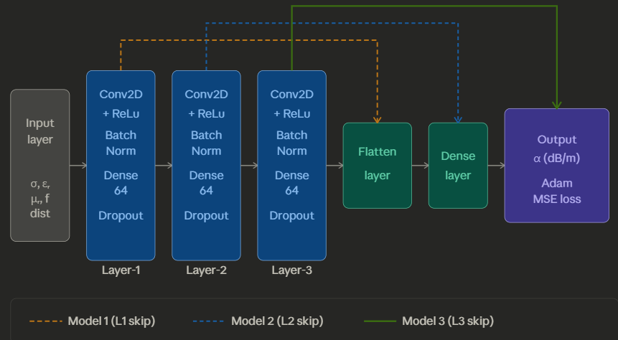

EXPERIMENTS
The primary goal of this project is to evaluate AI-based prediction of electromagnetic wave attenuation across multiple lossy media types. Five media classes were considered — seawater, moist soil, biological tissue, concrete, and dry wood — selected based on their diverse and representative electromagnetic properties.
A synthetic dataset of over 10,000 samples was generated by analytically computing the attenuation constant (α) across varying combinations of conductivity (σ), relative permittivity (εᵣ), relative permeability (μᵣ), frequency (MHz to GHz), and propagation distance. The dataset was split 80/20 for training and testing. Logarithmic scaling was applied to frequency values and all inputs were normalized prior to training.
The ANN model was implemented in Python using TensorFlow/Keras, trained using the Adam optimizer with MSE loss, and hyperparameters were tuned based on validation loss curves. Figure 2 illustrates sample attenuation profiles across the five media types, with each row representing seawater, soil, tissue, concrete, and dry wood respectively, plotted against frequency.

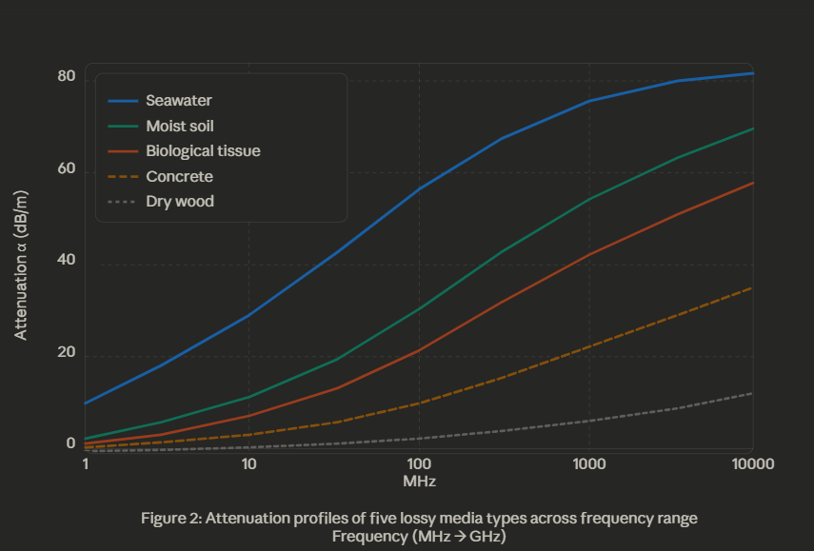

RESULTS

A synthetic dataset of over 10,000 samples was generated by computing the attenuation constant (α) across five lossy media — seawater, moist soil, biological tissue, concrete, and dry wood — using varying combinations of σ, εᵣ, μᵣ, frequency, and distance. The dataset was split 80/20 for training and testing, with inputs normalized and log-scaled before feeding into the ANN.
The model was trained in Python using TensorFlow/Keras with the Adam optimizer and MSE loss. Figure 2 shows the attenuation profiles of all five media types across the frequency range.

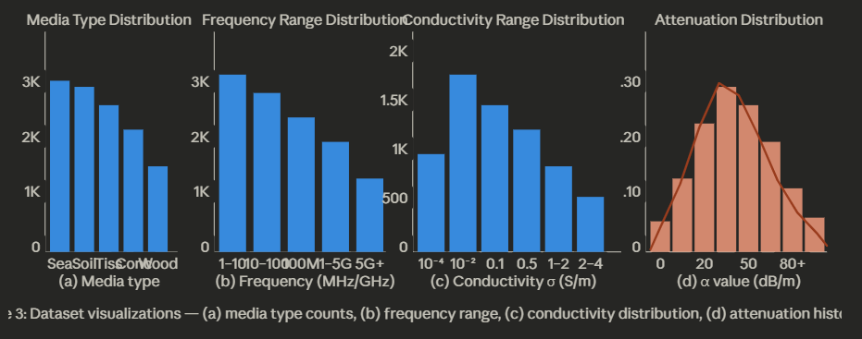

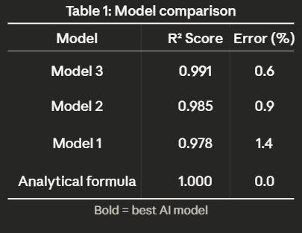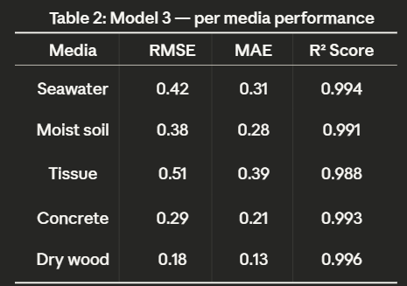

CONCLUSION and FUTURE WORK
In this project, we proposed an AI-based Artificial Neural Network (ANN) model for predicting electromagnetic wave attenuation in lossy media. We discovered that to accurately predict the attenuation constant (α) across diverse media types, it is necessary to consider not only the input parameters at a single layer but also the feature representations learned across intermediate layers through skip connections. This approach helped make the model more accurate and robust across all five media types — seawater, moist soil, biological tissue, concrete, and dry wood — achieving an R² score of 0.991 with less than 1% error compared to the analytical formula. In the future, one of our primary goals will be to extend the model to real-world measured datasets, incorporate additional media types, and explore deeper architectures such as physics-informed neural networks for improved generalization.

References

[1] S. Haykin, Communication Systems, 4th ed., John Wiley & Sons, New York (2001).

[2] D. K. Cheng, Field and Wave Electromagnetics, 2nd ed., Addison-Wesley, Reading, MA (1989).

[3] M. N. O. Sadiku, Elements of Electromagnetics, 7th ed., Oxford University Press, New York (2018).

[4] I. Goodfellow, Y. Bengio, and A. Courville, Deep Learning, MIT Press, Cambridge, MA (2016).

[5] F. Chollet, "Keras: The Python Deep Learning Library," Journal of Open Source Software, 2015. Available: https://keras.io

[6] P. A. Rosen, S. Hensley, I. R. Joughin, et al., "Synthetic aperture radar interferometry," Proceedings of the IEEE, 88(3), 333–382 (2000). DOI: 10.1109/5.838084.

[7] T. B. A. Senior and J. L. Volakis, Approximate Boundary Conditions in Electromagnetics, IET, London (1995).

